**Fanka Shundovska**

**IntelliJ – Selenium Basic Homework**

Firstly create new java project which will be called "selenium-pom-homework" and install all dependencies required.

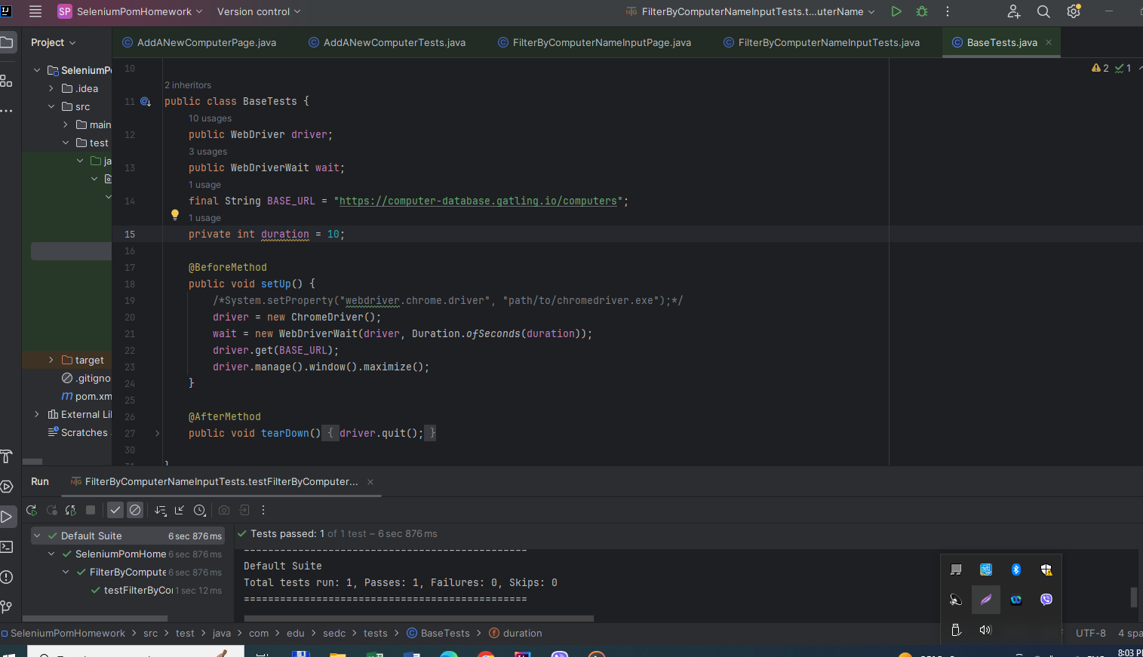

On the following web page https://computer-database.gatling.io/computers/new, using the Page Object Model design pattern create 2 tests.

First test is to click on "add a new computer" button, populate Computer name, Introduced and Discontinued fields and click add click create computer button.

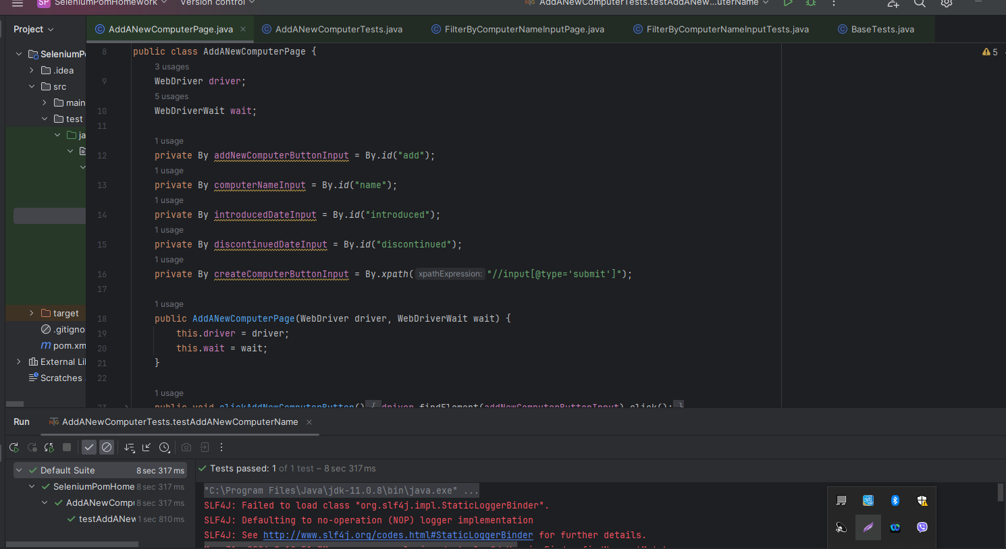

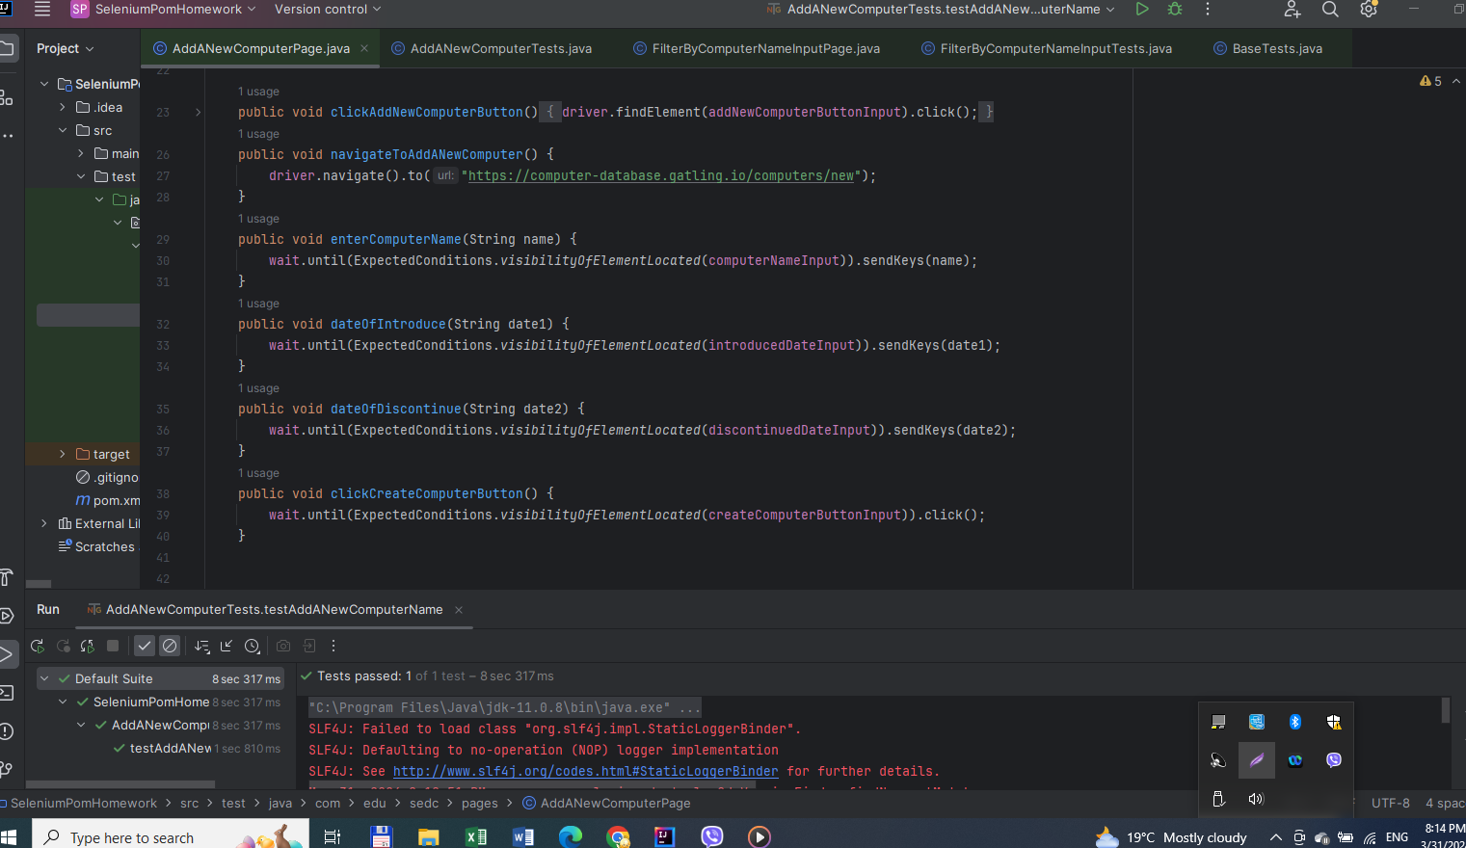

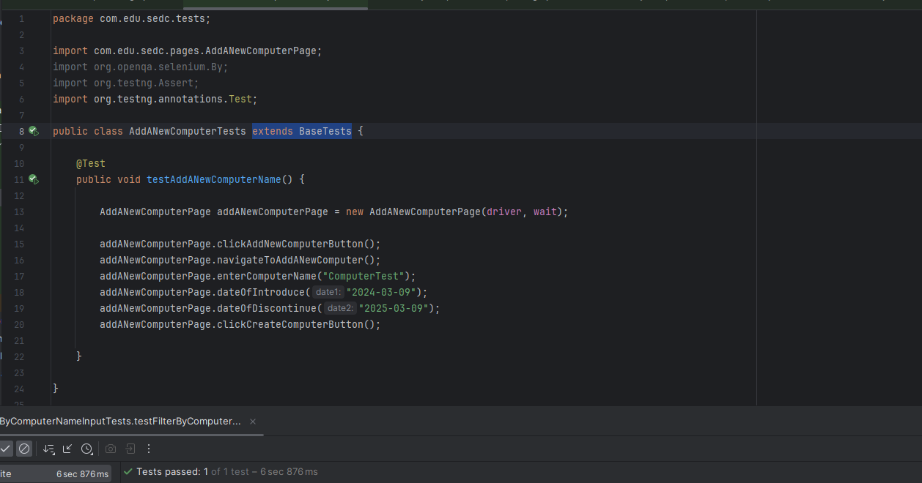

Second test is to enter some value in the "Filter by computer name input", click on "Filter by name button" and assert the text on the header displayed.

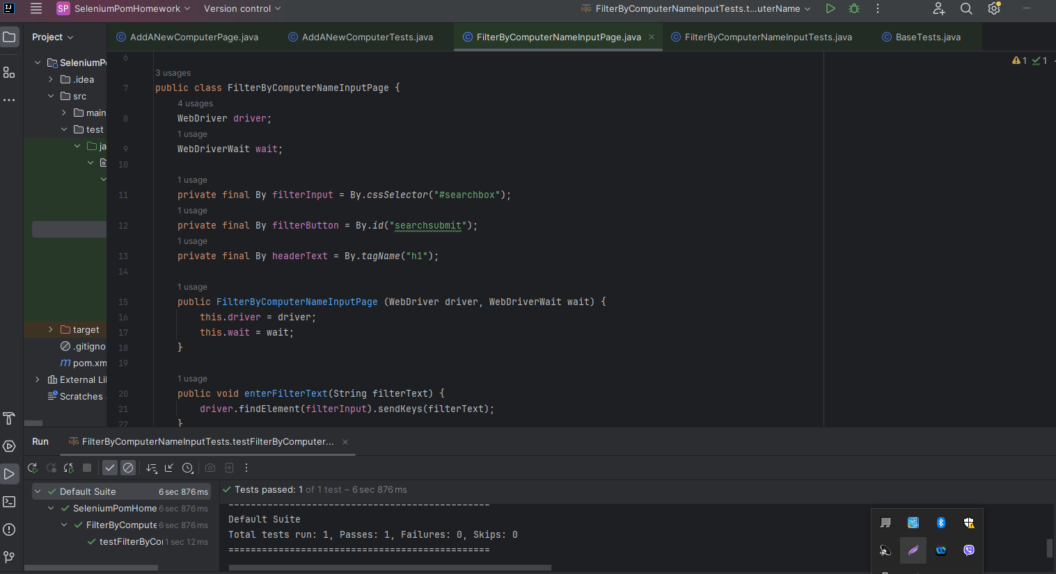

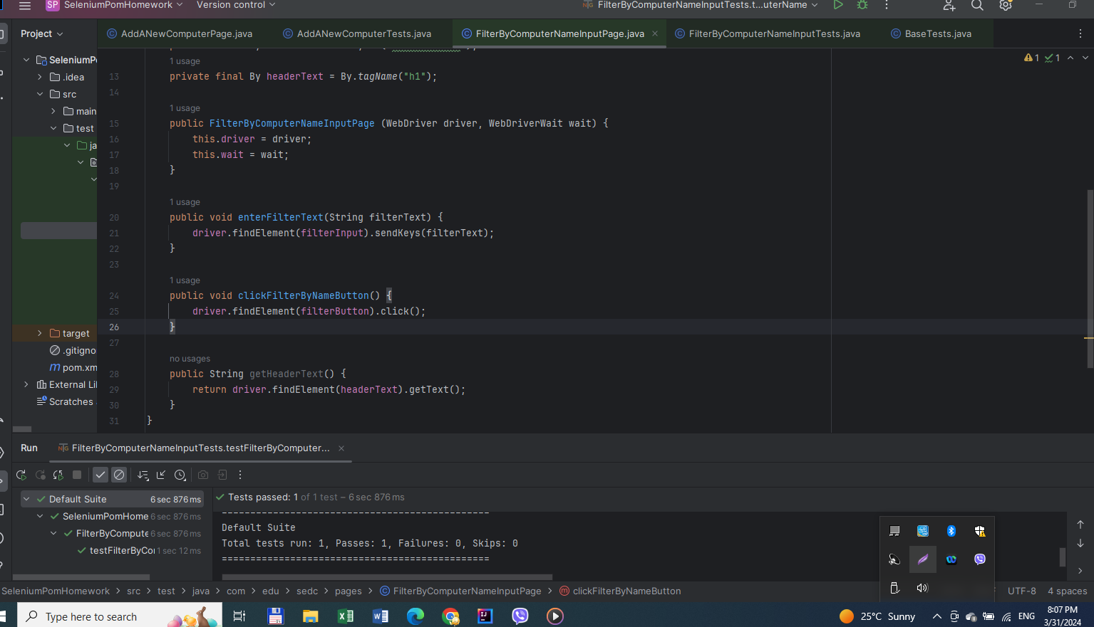

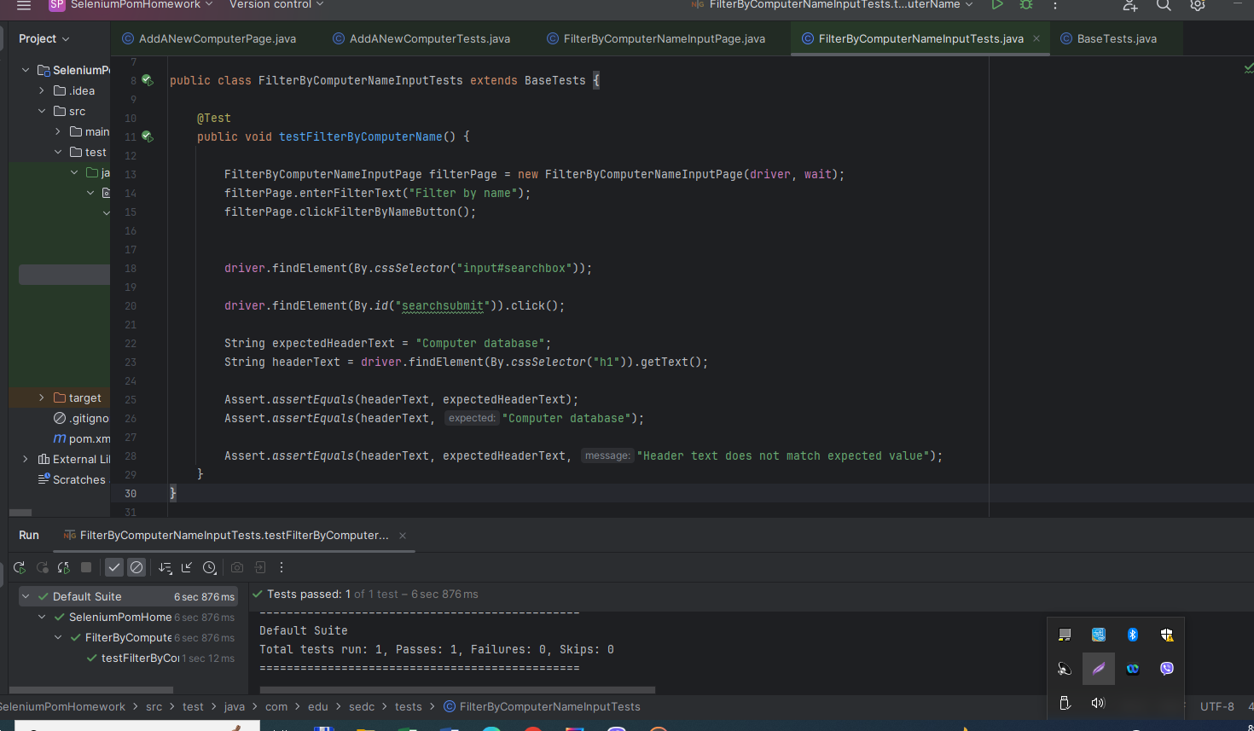

**Note:** Upload the homework as a zip file  (Exported Intellij project: File -> Export -> Project to zip file)